CP2403/CP3413: Project – Part 1 – 18% - Answer Template
Data Exploration, Management & Visualization
Due: (Friday, 13 March 2026 – Week 6 Friday)

First Name: Jack
Last Name: Kelly

Task 1: Histogram

Investigative Question:
What does the water salinity look like in California
quantitative variable:
Salinity (Salnty)

Data Processing Summary (80 words)
- Filtering applied:
The data was sorted into half percentages before being put into the graph, meaning that the x axis would have less options then grouping salinity by the hundredth percentage etc. This gave lightly grouped, more easily read data.
- Missing value handling:
The missing values were ignored in the plot section with the ‘dropna’ command – though this didn’t appear to cause much real difference as it seems salinity has always been measured.
- Rows remaining after cleaning:
As salinity seems to have ALWAYS been recorded, all 895,371 rows remained in the graph.
- Screenshot of .head() or summary output after preprocessing
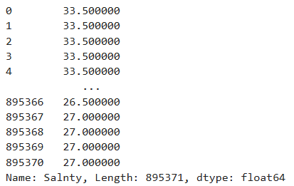

Analytical Reflection (120-180 words)
- Screenshot of result chart
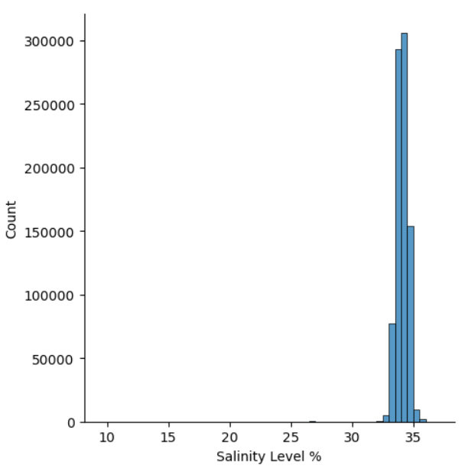
- Observed pattern/conclusion/finding (include at least one numeric reference):
We can see an extremely unimodal graph here, with the essentially all counts correlating in the 34-35% marker. This grouping indicates that the salinity of the water remains quite stable, however, there is one outlier group around the 27% mark. Generally, however, this graph indicates what would appear to be a healthy, stable body of water holding a quite standard bell curve at what appears to be the normal salinity off of the Californian coast.
- Impact of preprocessing:
Preprocessing has made this graph quite easy to read as with the accuracy of the salinity readings reaching the decimal points of tenths, hundredths and thousandths, this graph would still have the bell curve seen, but on a much smaller, complicated scale. Hence, the grouping of values by the half percentage has given readers a much easier time deciphering the trend, however obvious it may be.
- Limitation or alternative approach:
Were this done again, perhaps another quantitative variable could be measured alongside the salinity level to see how these levels impact other columns.

Task 2: Box plot

Investigative Question:
Did the quality code have anything to do with the types of values found for chlorophyll-a
categorical variable:
Quality Code (Chlqua)
quantitative variable:
Micrograms Chlorophyll-a per liter seawater (ChlorA)

Data Processing Summary (80 words)
- Filtering applied:
The Chlqua section was recoded to read as what the website stated each code meant, with a basic recode map run.
- Missing value handling:
For missing values, the NaN values were dropped from the ChlorA category to stop any errors from occurring in that area and deter excess 0 readings. The data was also reduced to just the two variables in this time, reducing load.
- Rows remaining after cleaning:
After cleaning, the data only contains 245,666 rows, roughly a quarter of what was originally seen
- Screenshot of .head() or summary output after preprocessing
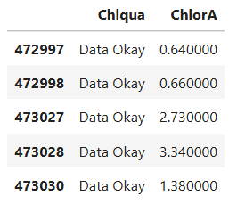

Analytical Reflection (120-180 words)
- Screenshot of result chart
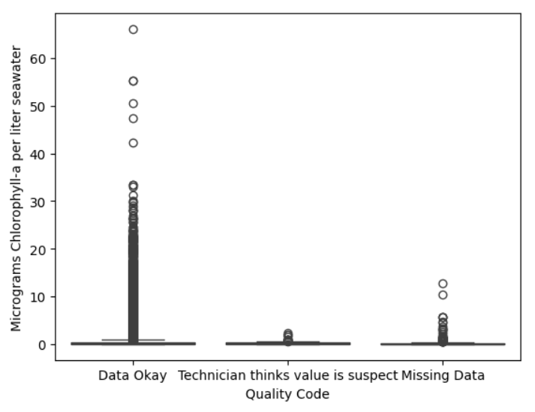
- Observed pattern/conclusion/finding (include at least one numeric reference):
Here we can see that only two real errors were associated with the reading of the Chlorophyll levels. The technician either believed the value was suspect, or there was missing data. These values all seem to be lower on average than the average ‘Data Okay’ reading which is interesting. This is seen particularly in the ‘Data Okay’s outlier of 60+ µg/L, which was not read as any kind of error despite it far exceeding any other reading. Juxtaposing this, the ‘suspect’ values never even pushed near the 5 µg/L level – and supposedly missing data generally stayed below 10 µg/L. This may be because measurements seldom passed 20 µg/L in general – so it was more likely an error would occur at said lower levels, with the average previously explored barely ever passing 0.5 µg/L.
- Impact of preprocessing:
The preprocessing made the data far more understandable for the categorical variable as the text makes more sense than a placeholder digit. For the quantitative variable however, the sheer number of values makes this a difficult plot to read.
- Limitation or alternative approach:
Another way to do this would be to reduce the number of values by perhaps exploring just one month, lowering the sample size and seeing numbers in more detail.

Task 3: Line chart

Investigative question:
How have water chlorophyll levels changed over the years it’s been measured?
quantitative variable:
Micrograms Chlorophyll-a per liter seawater (ChlorA)

Data Processing Summary (80 words)
- Filtering applied:
The depth ID contained the year, and to create more readable data, the year was extracted by grabbing the first 4 numerals and placing them in a new column; Year, then sorting into means so that the graph made sense and wasn’t overrun with data
- Missing value handling:
The Year and chlorophyll levels had their missing values removed at the same time to avoid data frame errors which would occur with a mismatch in length – this removed the years prior to the 1972, when they started recording this metric
- Rows remaining after cleaning:
We went from 895,372 rows to 43 for each year that had recorded the chlorophyll levels (most years since 1972).
- Screenshot of .head() or summary output after preprocessing
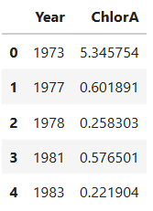

Analytical Reflection (120-180 words)
- Screenshot of result chart
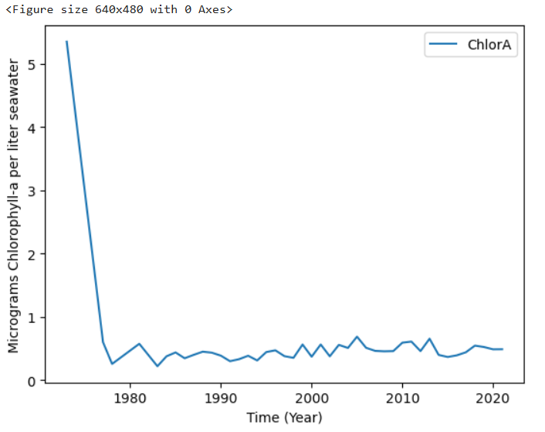
- Observed pattern/conclusion/finding (include at least one numeric reference):
Much like the previously made histogram; this line graph could be described as unimodal. This is because the peak of the graph is at one point, in this case, the start, with a reading over 5 µg/L on average in 1972, when the readings for chlorophyll-a started. This is followed by a sharp decline where the level stays beneath 1 µg/L whilst increasing ever so slightly over the next 40 years. This is interesting as it means that it’s more than likely the first year or so of measuring, the area encountered outlier levels of chlorophyll-a that have never been seen again. Apart from this, the only other real information extractable from this is that levels around 0.5 µg/L are the norm for the California coast, with some variation in said levels.
- Impact of preprocessing:
Preprocessing made this a smoother graph. Were the years not averaged out, there would surely be more disproportionate changes in the line graphs trajectory, and we would have a more difficult to read graph on our hands, with all 900,000 or so data entries crammed into one piece of information.
- Limitation or alternative approach:
One limitation could be that we cannot actually see the values throughout the years, just roughly where they are. Should it be possible then, one better approach would be to label the value of each years average on the graph itself.

Task 4: Bubble

Investigative Question:
Does measurement depth effect temperature and ChlorA production?
quantitative variable 1:
Depth (Depthm)
quantitative variable 2:
Temperature (T_degC)
quantitative variable 3:
Chlorophylla-a (ChlorA)

Data Processing Summary (80 words)
- Filtering applied:
The last years’ worth of data was used so as to not overfit the graph, allowed the data to be read more effectively. This equated to the last 2,465 rows (when the date changed from 2021 to 2020. The depth, temp, and chlorophyll values were all grabbed and set to numeric, with everything else dropped.
- Missing value handling:
Dropna was performed on the data frame, with all relevant variables called in the code at once to avoid mismatch errors.
- Rows remaining after cleaning:
After the dropna, only 1,702 of the 2,465 rows remained, quite a significant drop, however, this should make the data more reliable and avoids any errors that would be seen with empty values.
- Screenshot of .head() or summary output after preprocessing
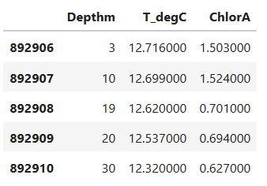

Analytical Reflection (120-180 words)
- Screenshot of result chart
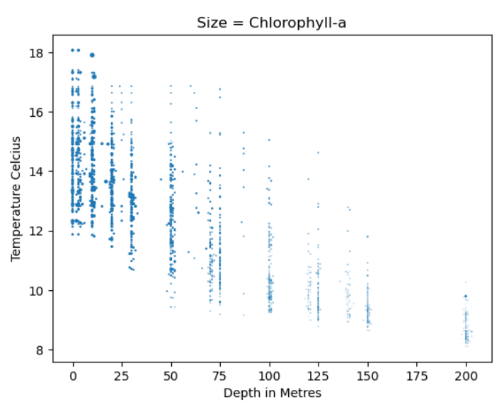
- Observed pattern/conclusion/finding (including at least one numeric reference):
This graph gives very clear and simple conclusions to the reader as a clear negative correlation exists between the temperature and depth. Though it was to be expected; the temperature overall dropped as the depth increased, with highs ranging from 12 to 18 degrees at surface level, and lows between 8 and 10 degrees 200 meters below. Perhaps interestingly, it was seen that the chlorophyll-a levels increased in these warmer, less deep waters, with larger bubbles being seen on the left of the graph at surface level in warmer temperatures. Opposing this on the right-hand side, we see very small bubbles in the 200-meter-deep waters that hold considerably lower temperatures – though it is still clear that the chlorophyll-a is present. The basic finding of this graph, is that chlorophyll-a seems to thrive more in less deep waters and in generally higher temperatures, though some outliers are evident, such as the 200 meter deep, and roughly 10 degree sample, which was abundant in chlorophyll-a relative to the rest of the ‘deep’ samples.
- Impact of preprocessing:
Pre-processing has allowed the easy viewing of these simple relationships and allowed for the evidence to be read clearly. This is seen as the graph depicts the previously mentioned negative correlation across the x axis, with naturally occurring variations still prevalent.
- Limitation or alternative approach:
One limitation would be that the data appears in grouped lines, perhaps to make the reading of this graph simpler, it could be averaged out based on the variables, giving a very simple average to be read for each depth and temperature.

Task 5: Selected Chart

Selected Chart:
Pie Chart
Investigative Question:
Does depth correlate with average Silicate levels?
Variables used
Variable 1: Silicate (SiO3uM)
Variable 2: Depth in meters (Depthm)

What is conclusion can you draw from your selected chart?
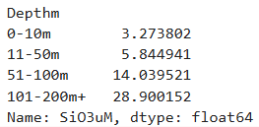

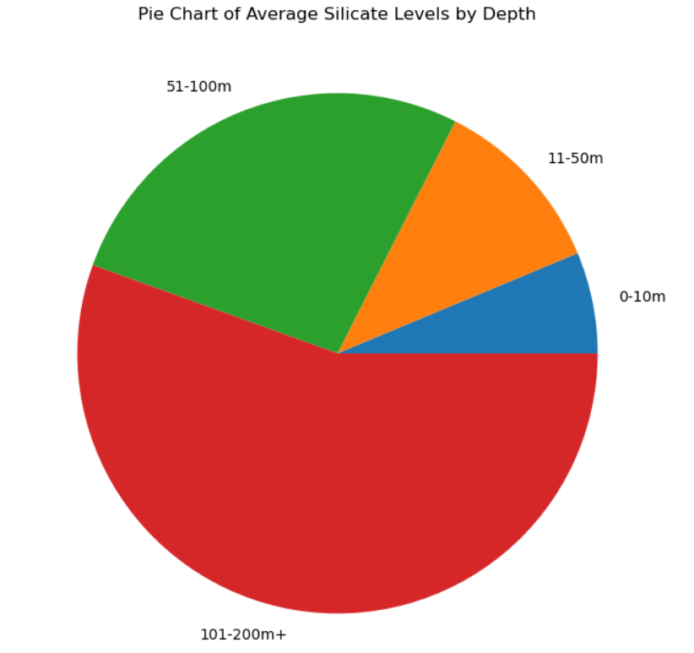

Looking at this chart, we can see an obvious relationship between the average silicate level and the depth of the water the sample(s) were found in. at 0-10m deep waters, silicate levels were only a small fraction of the pie chart, this then grew at 11-50m, together making up a little less than a quarter of the chart, and with 51-100m levels filling approximately a quarter of the chart on its own. However, the levels at 101-200m, despite being averaged over such a wide margin, made up more than half the chart on its own. This indicates that greater depths yield significantly higher silicate levels in water samples.

The preprocessing done on the data to reveal this pie chart averaged out the data at each depth bin – making the data more general in its approach, and hence, less accurate. However, it still gives a great indication as to the patterns seen in the data and still functions as evidence of the trend found.

A limitation of this chart would be that it doesn’t display any actual levels or specific numbers. This makes it hard to refer to as an actual source of evidence and is instead suited to a more overall display of a basic pattern, and at this it serves its purpose.

